

Oregon

AE Squadron

Of

Merit

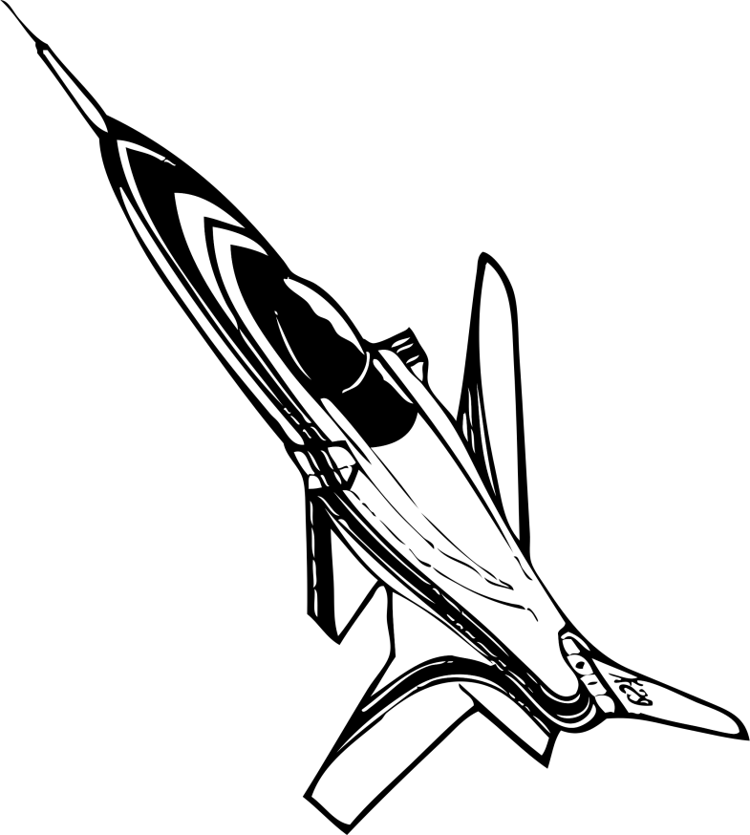

**AE Elements of Merit**

* Squadron AE Log
* Squadron AE Plan of Action
* Squadron Activity Report
* AEX Participation
* 85% Yeager Participation

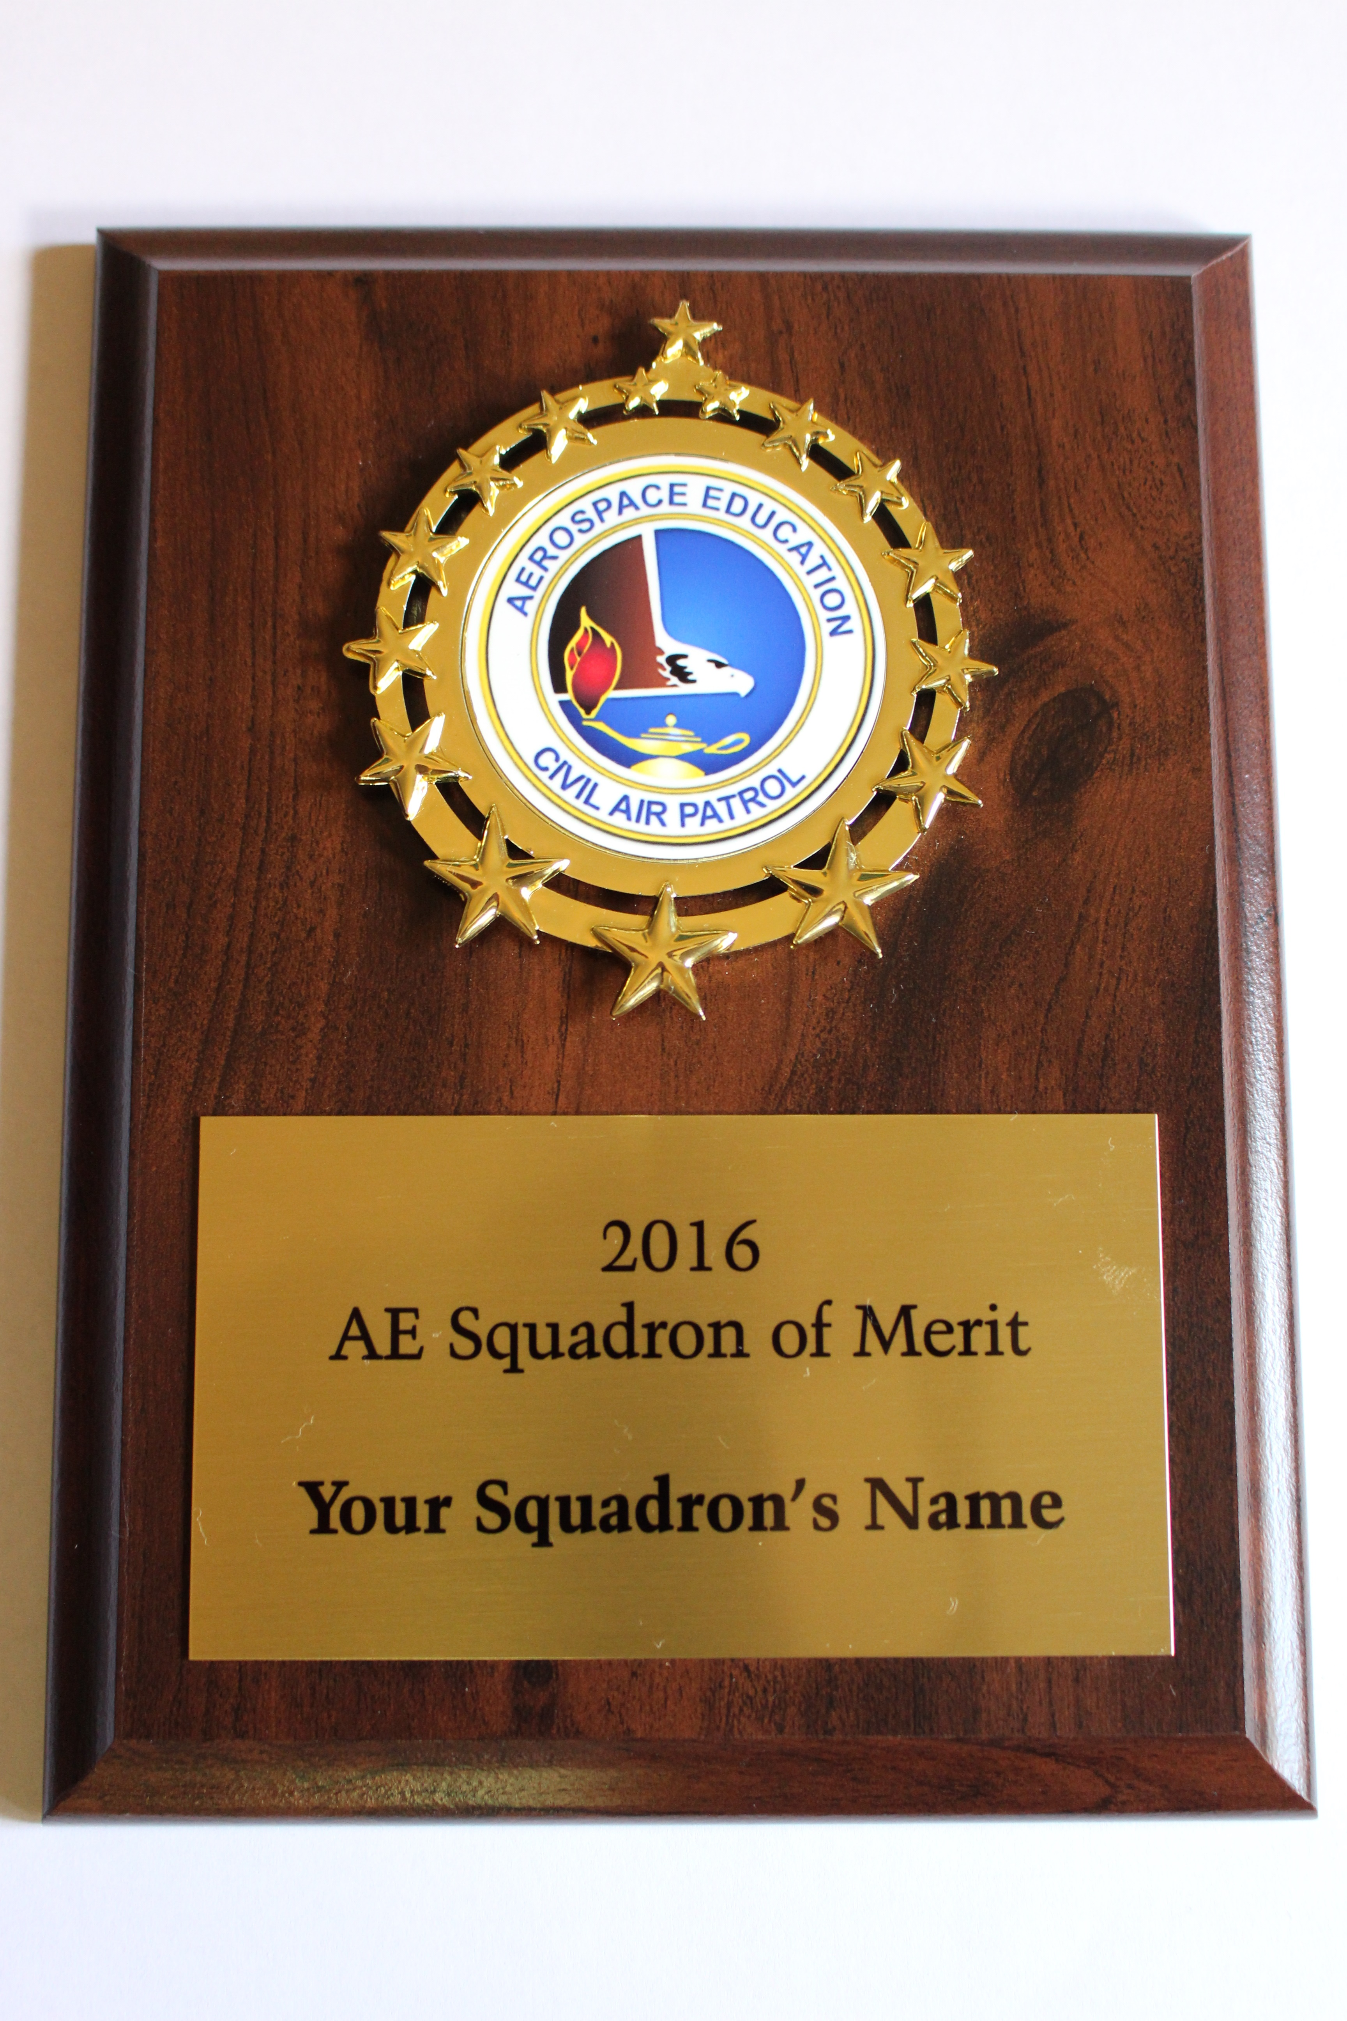



Aerospace Education Squadrons of Merit

In Oregon the AE Squadrons of Merit award will go to squadrons that have

completed the following 5 items:

1. They have maintained, completed and turned in an AE Unit/Squadron Activity Log to ORWG Director of Aerospace Education for the year
2. They have completed and turned in the AE Plan of Action in CAP e-services for the year
3. They have completed and turned in the AE Activity Report in CAP e-services for the year.
4. They have applied for and completed the CAP national AEX program of excellence for the current year.
5. They have obtained 85% or better in senior members achieving the Yeager award for the current year.

The process for earning this AE Squadron of Merit status is by notification of intent to complete these 5 items for stated year to the Oregon Wing DAE. The Oregon Wing Aerospace Education Department will check status of the participating units/squadrons at years end. It is the intent of Wing to award those units completing these 5 items will be awarded the AE Squadron of Merit plaque at the ORWG conference.

